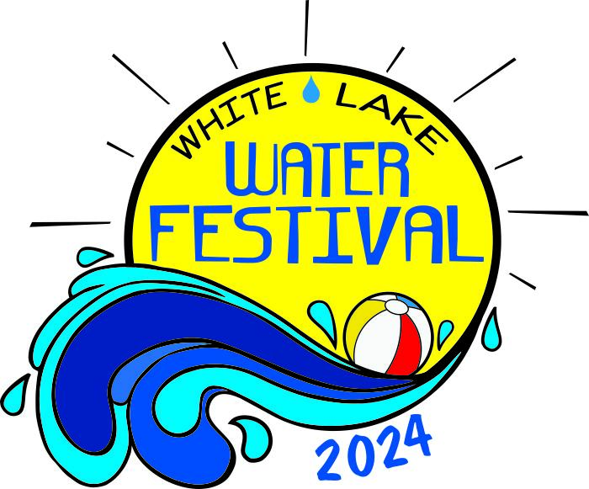
January 15, 2024

Dear Friend of the White Lake Water Festival:

We are glad to announce that the 46th White Lake Water Festival will take place on Friday, May 17, 2024 and Saturday, May 18, 2024. We are excited to start the summer on a high note with family-oriented entertainment and activities for the entire family in a safe atmosphere.

As always, we appreciate your support and generous contribution that helps make this weekend possible and such a success for the thousands of tourists who love to visit and support White Lake, Elizabethtown, and all of Bladen County during the festival weekend.

As a Level 3, 4 or 5 Sponsor, you can ensure your company’s name or logo will be printed on the 2024 White Lake Water Festival T-shirt, the brochure and contribution board and publicly recognized throughout various events during the festival weekend by returning your contribution no later than February 12, 2024.

Please know that everyone involved with the Water Festival appreciates your support.

Sincerely,
The White Lake Water Festival Committee
_________________________________________________________________________

Level 5 Sponsor $3000 Top billing & Stage named after business and all benefits below
Level 4 Sponsor $1500 Name/logo on billboards, brochures, social media & printed ads
Level 3 Sponsor $ 1000 Name on brochure, sponsor board, and mentioned at event
Level 2 Sponsor $ 500 Name on sponsor board and mentioned at event
Level 1 Sponsor $ 100 Individual who wants to support the Water Festival at White Lake
_________________________________________________________________________

Name of Business/Organization/ Individual:_______________________________________

Contact Person:___________________________ Phone:______________________

Email:___________________________________ 2024 Contribution: $___________

Please return your contribution to Elizabethtown - White Lake Area Chamber of Commerce, PO Box 306, Elizabethtown, NC 28337 by February 12, 2024.

You can also call to be invoiced: White Lake Water Festival Phone Number: 910-862-4368
Email address: admin@elizabethtownwhitelake.com Water Festival Coordinator Jeane’ Pope (910)583-3232. whitelakewaterfestival@gmail.com

